**Dynamic Healing Website Feedback-Prashansa**

1. **Need to improve text and maybe design for these boxes, ensure there is space before and after the text for easy readability.**

1. **On hovering, the grey text should turn black to indicate it is clickable.**

1. **Same Image used in both Preventive and Addictions, can be confusing.**

1. **Revise text here- Above are the images of the boy.., and adjust alignment of the text over photos (highlighted in yellow).**

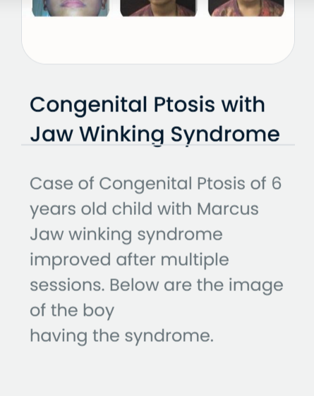 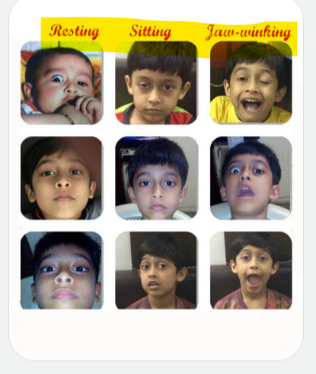

1. **Improve the success story format by using justified text and a little brighter font color. Also, remove the underline from the outlined issue as it overlaps with the text. If you are using a header for the issue in success stories, then use it across all stories to maintain consistency, I see a header in 1 and 3 but not in 2.**

**Last thing, the success story photos along with the text should fit in the window size, right now, we need to move up/down to check images and read together.   
**

1. **Customer Testimonials- Make it more attractive, if need be, cut short the content and keep it crisp to give a clear idea to the audience. Also, there is extra white space which doesn’t look good, so maybe, redo the design here.**

1. **Footer- Can refine the line “We are always ready to help you at any time, let’s talk together” with “We’re always here to help-let’s connect!”. Also there is an extra space after dynamichealing in the email id.   
   A screenshot of a phone appointment

   AI-generated content may be incorrect.**
2. **The navigation button (arrow) should be used both ways- if I am on the top page, I can directly go the footer with it and vice versa. Currently, it is in one direction.**

**Thank you!**